HSML Summary

HSML & the Spatial Web
The Spatial Web standard aims to set the guidelines that will define the Web 3.0, a computing environment that will blur the lines between the physical and digital worlds. The Spatial Web is an evolution of the internet, where we move from a 2D environment to a 3D virtual space that will allow people to interact with places, things, and each other (René & Mapes, 2019). To be able to place information spatially and contextually, we require a detailed map that explains how all the different data is related to each other in the system. This is where the Hyperspace Modeling Language (HSML) comes into play. HSML is a multi-dimensional ontology for encoding fundamental elements and the relationships between them (IEEE Computer Society, 2024). HSML does for the Spatial Web as HTML does for the WWW.

HSML Ontology Types
This ontology is composed of different types of elements, also known as classes. The highest class in the hierarchy is Entity. Entities are the base items used across the Spatial Web in HSML, and all the other classes are subtypes of the Entity base class. These include, but are not limited to, Activity, Agent, Contract, Channel, Credential, Domain, Hyperspace/Space, and Time (IEEE Computer Society, 2024). These classes allow to mark and identify the different elements that encompass both our physical and virtual reality, their meaning and relations are represented more clearly in Figure 1.

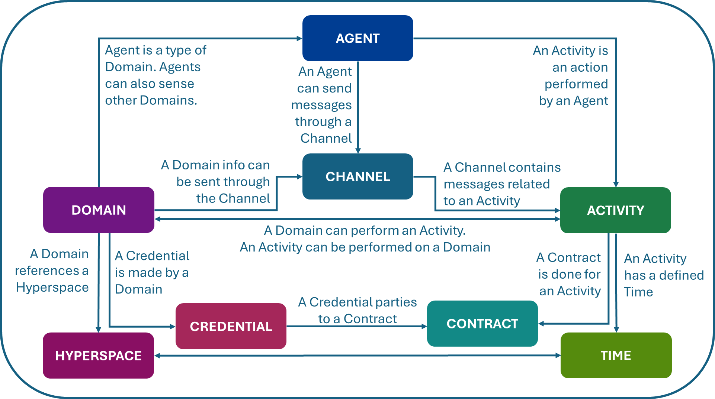
Figure 1. Map of the Entity subtypes that conform the HSML ontology.
HSML Schema
HSML encodes these Entities in a format, e.g. JSON (IEEE Computer Society, 2024). The JSON file organizes the information in a way that follows the rules and definitions set by the HSML schema. The JSON file of each Entity created must include the context (link to hsml.jsonld schema file), a unique identifier, name, description, type (either Entity or one of the other classes in the Spatial Web ontology), links to other Entities, and properties. An example of what a simple JSON file using our schema would look like is shown in Figure 2. By exchanging these text files that encode the information in the same format, the data can be read and used across different platforms.

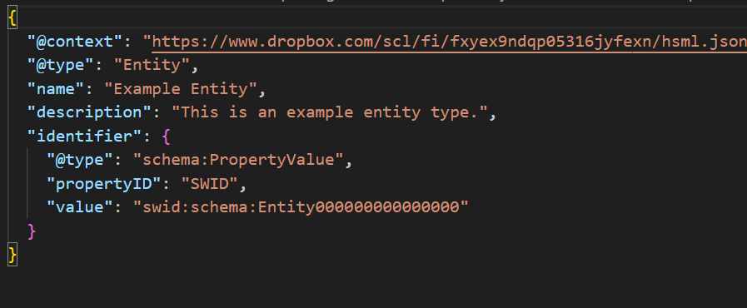
Figure 2. Entity JSON file Example using HSML Schema.

To register the identity of any user, space, or asset on the Spatial Web, we need a globally unique “decentralized identifier” (DID) based on W3C Standards (René & Mapes, 2019). The unique identifier receives the name of SWID (Spatial Web Identifier). However, no SWID method exists yet, so for now a DID key method can be used to implement the HSML schema.

Schema.org is a collaborative website that provides a collection of shared vocabularies for marking up web content, which big companies like Google follow. Making our HSML schema compatible with Schema.org offers a variety of benefits. Among them, it facilitates the adoption by future users, who are already used to Schema.org’s structure, and it allows us to save time by drawing from existing types and properties. Figure 2 shows the HSML Classes defined in the HSML schema context and the correspondent Schema.org types, from which each HSML class can draw existing relevant properties.

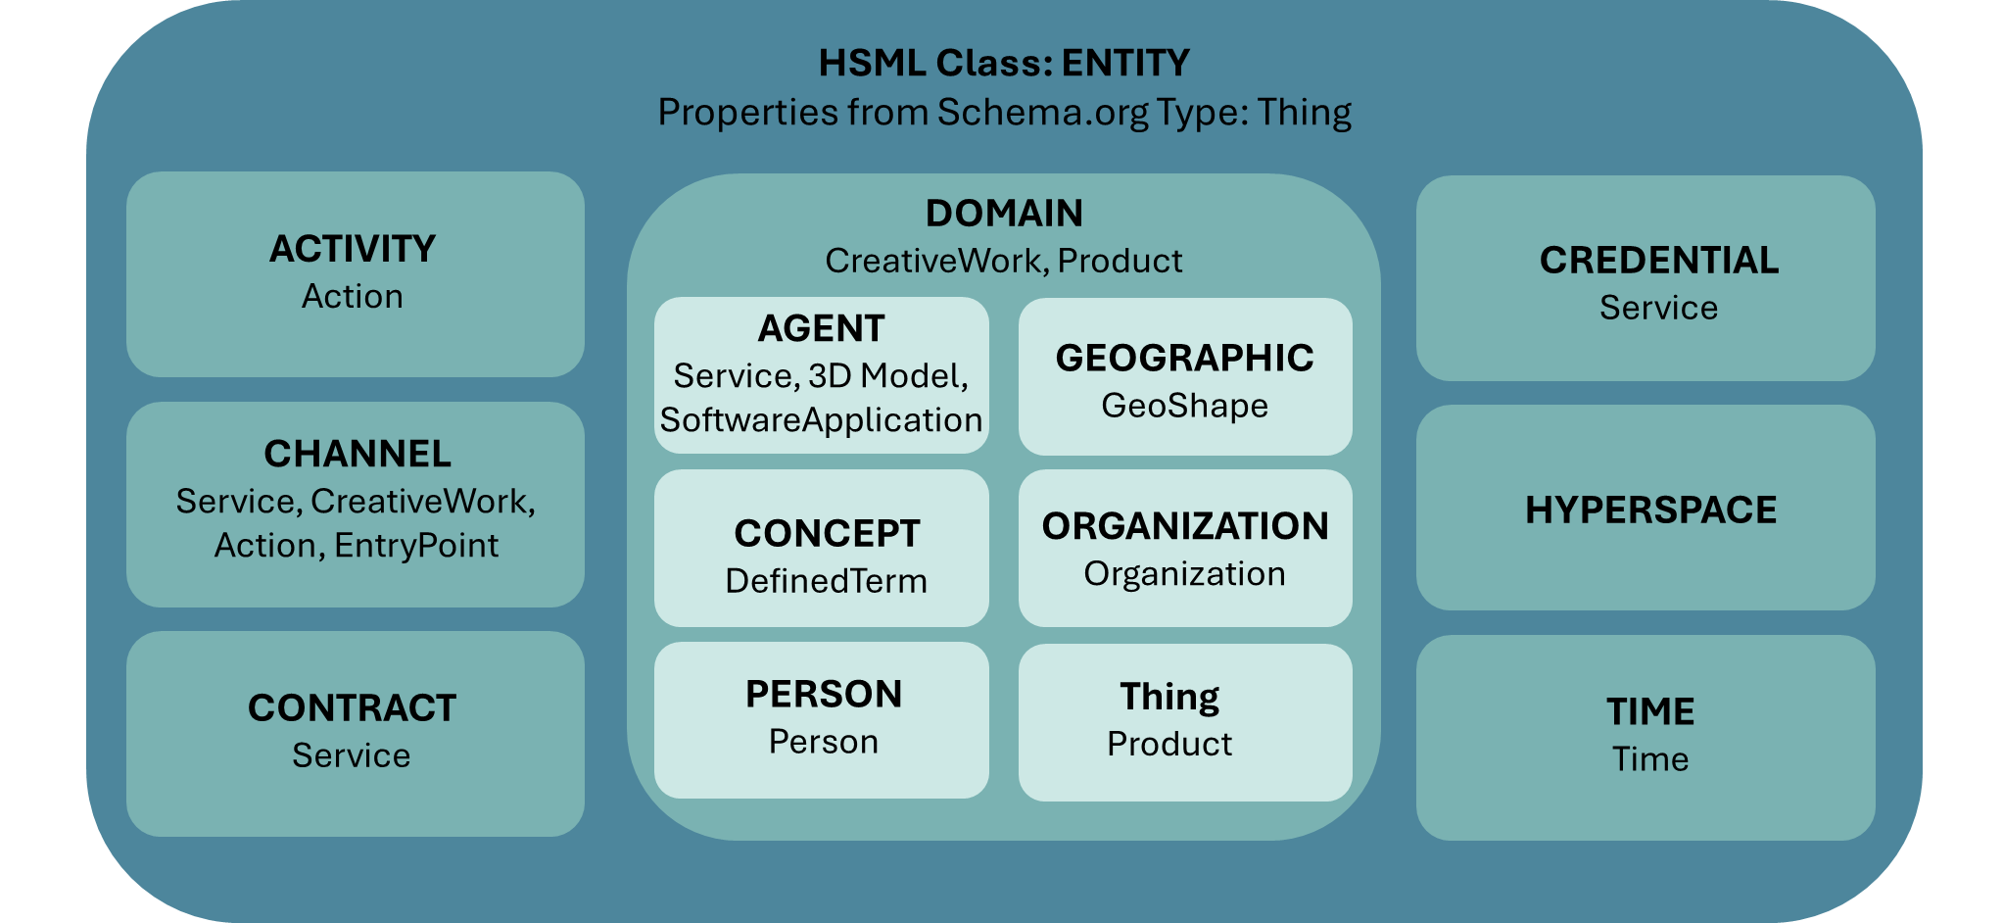
Figure 3. HSML Ontology Classes Hierarchy and their correspondent Schema.org Types, from which they draw some properties inside the HSML Schema.

Why is HSML Important for Us
There are three main reasons why we need to consider HSML in the context of Digital Twins interoperability:
- We need consistency in order to achieve interoperability between digital twins. And to interact, we must speak the same language, which is HSML.
- The Spatial Web describes a future in which we change from a 2D to a 3D view, in a both spatial and contextual approach. Thinking about the context, this is the connections with all the other elements, is also of paramount importance to Digital Twins. As we must not only define the digital twins’ 3D models but also the space they occupy, who they belong to and who has access to them and give them a unique identifier that allows them to be exchanged safely.
- Also, one of the key features of the Spatial Web standard and HSML, is the consideration of safety and trustworthiness through its Credentials, Contracts, and Decentralized Identifiers. This regard for a safe exchange of assets is one of the things that make HSML so unique.

HSML Schema Use Case:
To better showcase how this HSML schema comes into play, this use case shows the Entities involved when two digital twins interact with each other. Figure 3 displays the relationship between all the elements of the example.
- Two Organizations, Company A and Company B, sign a Contract to work together on a space mission to the Moon.
- The Rover of Comp. A will be carried inside the Lander of Comp. B. (Agents)
- Once they reach the Moon, the Rover will leave the Lander. To make sure this Activity is developed without any problem, Comp. B needs to work with the model of the Lunar Rover and run some simulations.
- A Credential is issued by Comp. A, authorizing Comp. B users (Person) to have access to the 3D Model of their rover for a Period of 3 Months (Time).
- The model of the Lunar Rover is in Unreal, and the model of the Lander is in Omniverse; both have a Moon surface environment modelled. The Hyperspace must consider, the location (the Moon), and the appropriate coordinate systems and transforms needed to go from one platform to the other.
- All the messages and communications related to this Activity are carried out in a Channel.

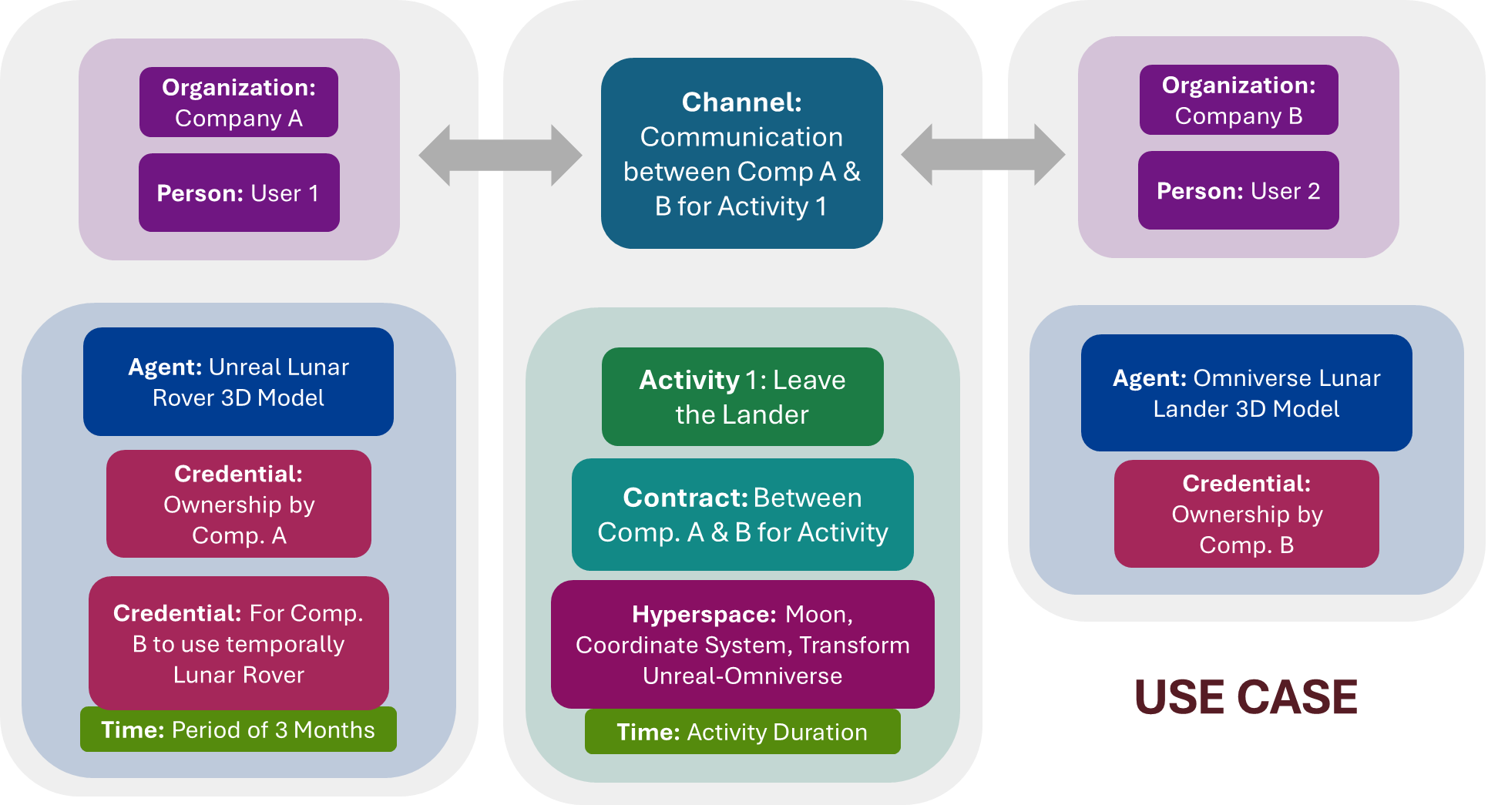
Figure 4. Use Case of HSML Schema. The diagram displays all the Entities mentioned in the Use Case and how they are related to one another to show the interaction between all the classes inside the HSML Schema in a possible real-life example.

Bibliography
IEEE Computer Society, C. -A. (2024). Title: Draft Standard for Spatial Web Protocol, Architecture, and Governance (P2874/D3.1). Piscataway, NJ: IEEE.
René, G., & Mapes, D. (2019). The Spatial Web.

